Trigger based ultrasonic sensor noise filtering

Owen Lu

Electroimpact Inc.

owenl@electroimpact.com

*Abstract*— Previously a combination of median and moving average filtering had been tested by their ability to remove ultrasonic signal artifacts. Although combining the two results in very accurate as well as robust performance, the computational time penalty is simply too great to be used with the current implementation.

# Introduction

The key of this implementation is that it is fast, memory efficient and robust. However, this method does introduce problems regarding false readings during spool replacement, thus a reset routine must be implemented to compensate for such errors.

# Assumed Artifact behaviours

During all testing conducted on multiple ultrasonic sensors, readings would fluctuate to a high signal and then return to its nominal value. Each step was for a brief period of time (fractions of a second), so that the diameter could not feasibly change drastically in such a short period. Below is an example of voltage spikes causing a sharp decrease in diameter measurements.

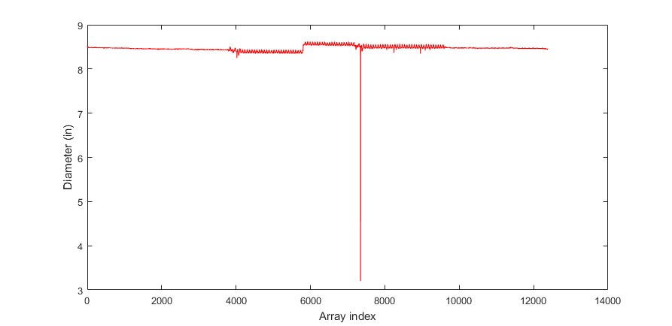

Figure 1 – Diameter reading artifact caused by voltage spike

# Filter characteristics

The filter simply uses a condition to determine whether the new reading should be taken or rejected and simply holds the last good reading until a new reading that passes some trigger condition is met.

The specific implementation follows the procedure below:

1. Calculate the difference between current and previous reading
2. If the difference exceeds a statistically improbable value (3 Sigma) set trigger
3. During trigger, hold last good value of diameter for calculations
4. Reset trigger when difference exceeds the trigger threshold again and resume taking new readings

# Trigger definition

During operation, there always exists a fluctuation in the diameter readings due to the imperfect spool geometry as well as wobble due to eccentricity. The effects of noise is very small compared to the aforementioned factors. During operation, the 3 standard deviation value was approximately 0.25 inch diameter variation. Thus, any reading corresponding in 0.25 inch changes or more will be rejected with the previous value used.

# Code

The code used in the SmartMotor language pertaining to the filter is given below.

1. a = INA(V1,2)
2. aaa = a-aa  ' Take the difference reading
4. IF ABS(aaa) > 200
5. a = aa
6. ELSE
7. aa = a
8. ENDIF

# Long payout test

In order to test the robustness of the filter, a payout test conducted for 5 minutes with two ultrasonic sensors was done. Figure 2 is a plot of the payout test. It can be seen that all large voltage spikes have been removed during operation. Thus, corresponding gain errors due to artifacts have also been removed. The standard deviation was 3mV.

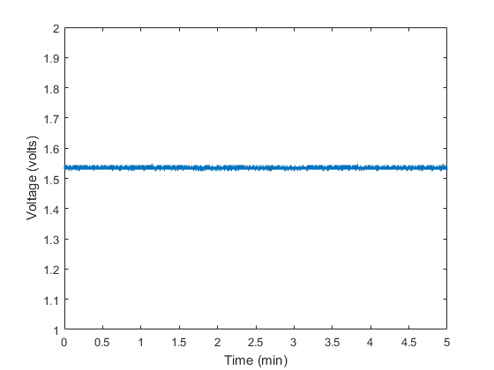

Figure 2 - Extended test with shielded cable

# Conclusion

This method will be used during tool changer testing in the absence of other smoothing filters as low material triggers are not the main objective of study.